

Lesker-2 TiN Characterization

Standard Operating Procedure

Akash Levy, Jung-Soo Ko

ENGR 241 Winter 2020 Report

# Introduction

The motivation of this project was to develop a sputtered TiN process in SNF with properties essential for non-volatile memory (NVM). These properties include low resistivity (< 100 µW cm), low surface roughness (< 1nm for a 30nm deposited film), and low oxygen content (< 5%). The findings presented here should benefit many lab members, since TiN is used across many types of emerging non-volatile memories, such as RRAM, FeRAM, and PCRAM, as well as many other applications; in the past, these thin films have typically been produced outside of SNF (in Allen 111X) using reactive sputtering of a Ti target. Our goal was to develop a process for sputtering of NVM-quality TiN using the new Lesker sputtering tool (Lesker-2) that resides inside the cleanroom. This tool can achieve the high-vacuum pressures necessary for TiN films with low levels of oxygen contamination.

Using the Allen 111X TiN recipe as our reference, we sputtered and tested TiN films in both Lesker-1 and Lesker-2 to try to lower oxygen-contamination, surface roughness, and resistivity. We also measured deposition rates using measurement of step height with a “Sharpie liftoff” technique. We summarize our findings in this report and have made all of the raw data collected available to the SNF community for future use. We have also stored the samples in case any SNF members would like to perform further testing on the thin films we have deposited.

**All data and scripts for processing the data are available here:** [**https://github.com/akashlevy/ENGR241-Q2**](https://github.com/akashlevy/ENGR241-Q2)

# Process Flow

## High-Level Diagram



## Detailed Process Steps

1. Obtain Si wafer and perform RCA clean wafer
   1. Type of wafer does not matter as long as substrate is allowed in clean tool
   2. The cleaning process is well documented: [Wet Bench Clean](https://snfexfab.stanford.edu/snf/operating-instructions/wet-bench-clean1and2), [Training Video](https://www.youtube.com/watch?v=jL4RJ1gMZ-M&feature=youtu.be)
2. Grow at least 50nm SiO2 with thermco
   1. This layer is required for electrical isolation of bottom contact and Si bulk
   2. Recommended method: 20 min. of 900˚C wet growth
   3. WETOX recipe with default settings and time/temp from above
   4. Exact thickness is not important: make sure at least 30nm are present for isolation from Si bulk, else resistivity measurements will be skewed
   5. Not necessary for glass wafer
3. Use Woollam or Nanospec to check oxide thickness
   1. Use recommended settings from [Woollam In-Depth](https://snfexfab.stanford.edu/snf/operating-instructions/woollam-ellipsometer-in-depth)
   2. 1mm Si layer, 50nm SiO2 layer, fit SiO2 layer, n-k fit should not be necessary
4. Sharpie for step height
   1. Draw a line going from the major flat to the center of the wafer
   2. Example:

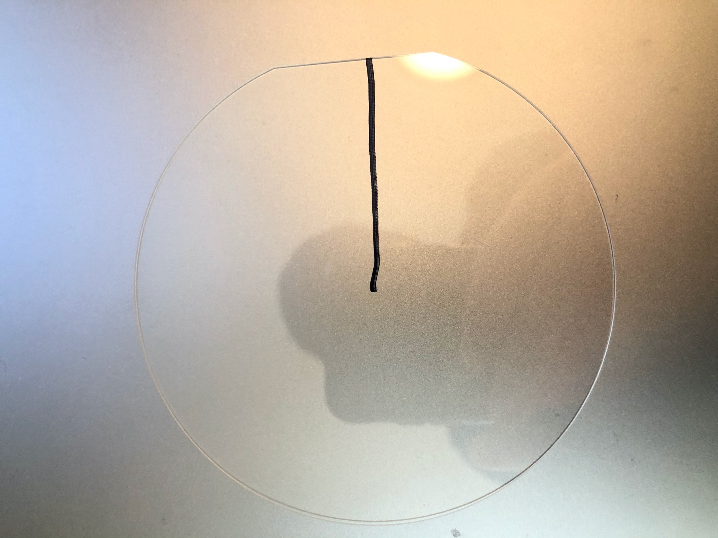

1. TiN sputter deposition
   1. AJA sputtering tool in Allen 111X
      1. Target: Ti
      2. RF Power: 200W
         * 150W also ok; different dep rates
      3. Wafer Bias: 100V
         * DC bias ends up being 92-94V on AJA in practice
      4. Ar Flow: 30 sccm
      5. N Flow: 3 sccm
         * Unit conversion means that this is written as 30 on AJA somehow
      6. Set Pressure: 2.15 mTorr
         * 1.8-1.9 mTorr on AJA in practice
      7. Load sample and wait for 1e-7 base chamber pressure
      8. Turn on plasma for another (conductive) target e.g. Al, GeTe, to ease plasma ignition for Ti target
      9. Turn on plasma for Ti target
      10. Turn off bias for the other target
      11. 20s ramp-up of Ti target RF power
      12. 2 minutes pre-sputtering of Ti target (shutter closed, no wafer bias)
      13. 20s ramp-up of wafer bias
      14. Open shutter and deposit for 1800 seconds
      15. Close shutter
      16. 20s ramp-down of Ti target RF power
   2. Lesker-1 sputtering tool
      1. [Lesker-1 Instructions](https://snfexfab.stanford.edu/snf/operating-instructions/lesker-operation-manual)
      2. Target: TiN
      3. RF Power: 150W, 200W, 250W (do not go above 250W!)
      4. Wafer Bias: 100V
         * Turn on wafer bias during power ramp-up phase (shutter delay)
      5. (Recommended) Pre-sputter target for at least 30 min.
         * Use same settings as regular deposition but use 250W
         * Load empty sample carrier to prevent damage to heating element
      6. Set Pressure: 2 mTorr (Ar)
      7. Use downstream control recipe
         * Means you can specify upstream gas flows and pressure is controlled by adjusting the gas outflow
      8. Ar Flow: 30 sccm
      9. Chamber pressure: < 1e-6 Torr recommended
         * Chamber pressure is usually not that good
   3. Lesker-2 sputtering tool
      1. Similar to Lesker-1, use [Lesker-1 instructions](https://snfexfab.stanford.edu/snf/operating-instructions/lesker-operation-manual) as reference
      2. Target: TiN
      3. RF Power: 150W, 200W, 250W (do not go above 250W!)
      4. Wafer Bias: 100V
         * Turn on wafer bias during power ramp-up phase (shutter delay)
      5. (Recommended) Pre-sputter target for at least 30 min.
         * Use same settings as regular deposition but use 250W
         * Load empty sample carrier to prevent damage to heating element
      6. Set Pressure: 2 mTorr (Ar)
         * Until PID on pressure controller is fixed, you must incrementally decrease set pressure to target value
         * Recommendation: start with 5 mTorr and decrease in steps of 0.5 mTorr, waiting for pressure to settle after each step
      7. Upstream control recipe
         * Means that you cannot set gas flows manually
         * Gas flows are adjusted automatically to match set pressure
      8. Chamber pressure: wait until ~1e-8 Torr (achievable!)
      9. Sputter time: 30 min. for qual wafer recommended (~40nm)
2. Prometrix Resistivity
   1. [Prometrix Instructions](https://snfexfab.stanford.edu/snf/operating-instructions/prometrix-resistivity-mapping-system)
   2. Use default probe (probe B) and default measurement settings
   3. Perform 5-point measurement and check that variance is relatively low
3. Step height measurement: Alphastep
   1. Using a foam swab dipped in acetone, vigorously rub off the sharpie mark starting from the wafer flat and going towards the wafer center
   2. This should liftoff the TiN in these locations
   3. Use Alphastep to measure the step height across boundary of the Sharpie mark
   4. Exact settings do not matter as long as step is clear, and bowing is properly accounted for post-measurement
   5. Be sure to test in several locations along the mark, as the step height can vary across the length of the wafer
4. Cleave wafer for AFM and XPS
   1. Demonstration: https://www.youtube.com/watch?v=IRoIXjxIcBQ
   2. Scrape lines along crystal direction
   3. Gently bend wafer until it shatters
   4. Make 1cm x 1cm sample by repeated cleaving
5. Compositional analysis with XPS: PHI VersaProbe 3
   1. [PHI VP3 Instructions](https://snsf.stanford.edu/equipment/xsa/docs/PHI%20VersaProbe%203%20Beginner%20User%20Guide.pdf)
   2. Load samples into system
   3. Use e-neutralization
   4. Z-align samples and verify that alignment is relatively consistent across samples
   5. Perform survey scan for all samples
      1. Recommended settings: 2 sweeps, 224 eV pass energy
      2. Verify in MultiPak that peaks for Ti2p, C1s, O1s, N1s are identified
   6. Perform high-resolution scans
      1. Recommended settings: 2 sweeps, 55 eV pass energy
      2. Verify in MultiPak that peaks for Ti2p, C1s, O1s, N1s are identified
   7. Perform depth profile
      1. Use Ar sputter gun
      2. Include Si2p in addition to Ti2p, C1s, O1s, N1s from before
      3. Use appropriate sputtering setting for estimated thin film thickness
      4. Do 5-10 sputter cycles per sample
      5. Plot composition with MultiPak and use “% AC” for atomic composition
6. Surface roughness with AFM: Asylum-AFM or Bruker AFM
   1. Measurement should be done at a small scan area, since using a larger scan window tends to average out roughness
   2. Recommended window for small area scan is 500nm x 500nm
   3. Large scan area is helpful for understanding the surface topology
      1. Helps identify and measure grain boundaries, residues, pinholes
   4. Surface roughness measurement should be taken in deposited area and area where Sharpie was lifted off (Si/SiO2 substrate)
      1. Subtract background roughness from Si/SiO2 substrate

# Results and Findings

## Literature Review on TiN Sputtering

* TiN films absorb a high concentration of contaminants including hydrogen, carbon, and oxygen when they are exposed to air after deposition
* With the target–substrate distance set to 88 mm the **contaminant levels increase from ∼0.1% to ∼10% as the pressure is increased from 2 to 9 mTorr** in an AJA sputtering system with high-purity (99.9999%) Ar and N2 gas lines
* The contaminant concentrations also correlate with in-plane distance from the center of the substrate and increase by roughly two orders of magnitude as the target–substrate distance is increased from 88 to 266 mm
* Contaminants strongly influence properties of TiN thin films
* **Resistivity of stoichiometric films increases by around a factor of 5 as the oxygen content increases from 0.1% to 11%**
* Energy of the sputtered TiN particles plays crucial role in determining the film properties
* Important to precisely control the energy of these particles to obtain high-quality TiN

**Source:** Ohya, S., B. Chiaro, A. Megrant, C. Neill, R. Barends, Y. Chen, J. Kelly et al. "Room temperature deposition of sputtered TiN films for superconducting coplanar waveguide resonators." *Superconductor Science and Technology* 27, no. 1 (2013): 015009.

## TiN Wafer Pictures

### AJA

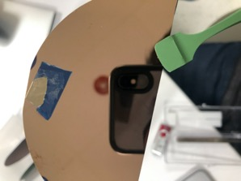

### Lesker-1

### Lesker-2

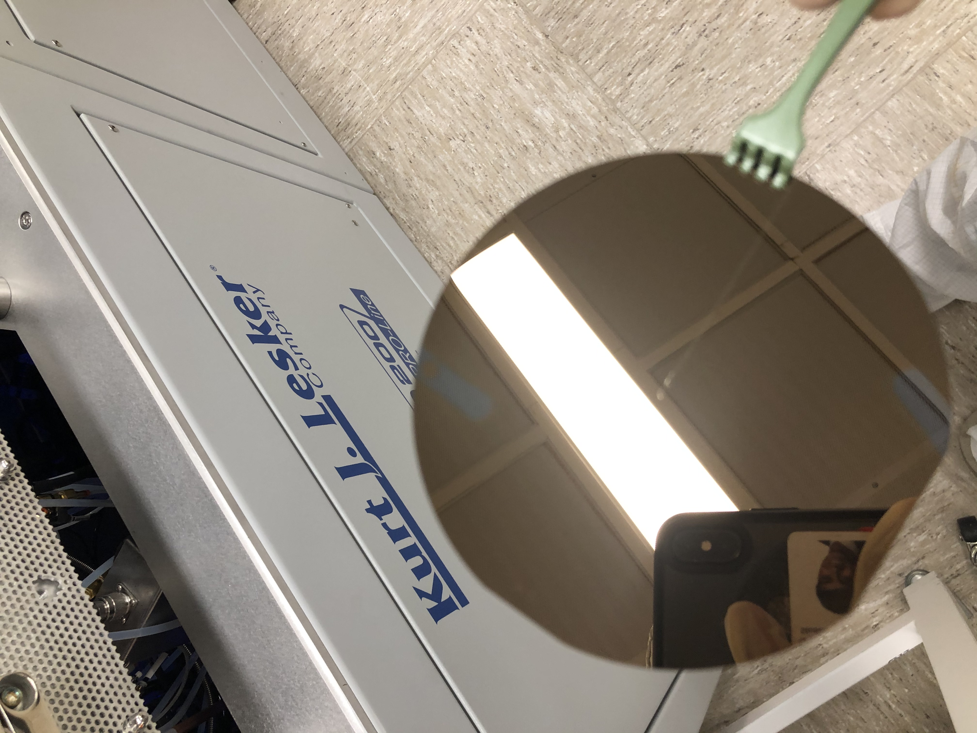

## XPS Compositional Data Examples

### AJA Survey Scan (Surface)



### AJA High-Resolution Scan (Surface)



### AJA Depth Profile



## AFM Surface Roughness Plot Example (AJA)



## Data High-Level Takeaways

See table on next page for summarized data.

* Lesker-2 can achieve much lower chamber pressures (4e-9 Torr minimum observed with sample Y2) than Lesker-1 (1e-6 Torr minimum observed with sample X2)
* TiN target sputtering does not seem to produce as good films as reactive sputtering of a Ti target (see results for sample A1 vs. Y2)
* Nitrogen gas flow does not matter much for sputtering of a TiN target (see results for sample X3 vs. X4)
* Lower deposition pressure leads to better quality films and lower contamination (see results for sample X2 vs. X3)
* Pre-sputtering can lead to TiN films with lower resistivity (see results for Y1 vs. Y2)
  + Note that X4 was deposited directly after X3, so X3 acted as a “pre-sputter” for X4. Therefore, X4 had the TiN pre-sputtered for close to an hour in actuality
* Deposition rate is dependent on choice of wafer material (see results for Y2 vs. Y3)
  + This likely has to do with differences in wafer bias effect
* Lower RF power on TiN sample seems to produce lower oxygen contamination (see results for sample Y3 vs. Y4)

Note that more data should be taken to qualify and validate these findings. In particular, it would be good to have statistical validation across multiple runs with the same parameters.

**Table of Sputtered Film Properties**

|  |  |  |  |  |  |  |  |  |
| --- | --- | --- | --- | --- | --- | --- | --- | --- |
|  | AJA: A1 | Lesker-1: X2 | Lesker-1: X3 | Lesker-1: X4 | Lesker-2: Y1 | Lesker-2: Y2 | Lesker-2: Y3 | Lesker-2: Y4 |
| **Target/Wafer** | Ti/Si+SiO2 | TiN/Si+SiO2 | TiN/Si+SiO2 | TiN/Si+SiO2 | TiN/Si+SiO2 | TiN/Si+SiO2 | TiN/glass | TiN/glass |
| **Base Pressure** | ~1e-7 Torr | ~1e-6 Torr | ~3e-6 Torr | ~1e-6 Torr | ~1e-7 Torr | ~4e-9 Torr | ~1e-8 Torr | ~2e-8 Torr |
| **RF Power** | 200W | 200W | 200W | 200W | 200W | 200W | 250W | 150W |
| **Gettering/**  **Chamber** | 2 min TiN ↑ | 5 min Ti pre,  5 min TiN ↑ | 10 min Ti pre,  5 min TiN ↑ | 5 min Ti pre,  40 min* TiN ↑ | 5 min TiN pre,  5 min TiN ↑ | 30 min TiN pre,  5 min TiN ↑ | 30 min TiN pre,  5 min TiN ↑ | 30 min TiN pre,  5 min TiN ↑ |
| **Wafer Bias** | 100V | 100V | 100V | 100V | 100V | 100V | 100V | 100V |
| **Ar/N Flow** | 30/3 sccm ↓ | 30/3 sccm ↓ | 30/3 sccm ↓ | 30/0 sccm ↓ | 11.5/0 sccm ↑ | 11.6/0 sccm ↑ | 11.5/0 sccm ↑ | 11.5/0 sccm ↑ |
| **Pressure** | 2.15 mTorr | 30->3 mTorr | 20->2 mTorr | 20->2 mTorr | 15->5->2 mTorr | 15->5->2 mTorr | 15->5->2 mTorr | 15->5->2 mTorr |
| **Sheet Resistance** | 15.650 Ω/□ | 2428.0 Ω/□ | 304.8 Ω/□ | 129.9 Ω/□ | 121.2 Ω/□ | 54.4 Ω/□ | 43.5 Ω/□ | 110.2 Ω/□ |
| **Resistivity** | 67.25 uΩ cm | 6313 uΩ cm | 927 uΩ cm | 519.6 uΩ cm | 969.6 uΩ cm | 217.6 uΩ cm | 326.2 uΩ cm | 639.2 uΩ cm |
| **Uniformity/Color** | Excellent | Not Good | Okay | Okay | Okay | Okay | Okay | Okay |
| **Thickness/Time** | 43nm/1800s | 26nm/900s | 30nm/1800s | 40nm/1800s | 80nm/1800s | 40nm/1800s | 75nm/1800s | 58nm/1800s |
| **Roughness** | 0.67nm | 1.79nm | 1.66nm | 1.37nm | 0.86nm | 1.28nm | ? | ? |
| **Composition**  **(Ti:N:O)** | 47:52:1 | 38:39:23 | 43:43:14 | 43:43:14 | 46:41:13 | 47:40:13 | 45:42:13 | 48:45:7 |

** There was 35 minutes of pre-sputtering from X3 deposition occurring directly before X4. 5 minutes more of pre-sputtering was done after the Ti pre-sputter.

# Future Work

## Process Improvements

* Try reactively sputtered TiN
  + It is possible that the TiN target itself is oxygen contaminated
  + Reactively sputtered TiN should have lower oxygen contamination
* Determine composition of TiN target with XPS
  + Graham has lent a cracked target for measurement
  + Will determine if TiN target is the problem

## Data Improvements

* Standard device qualification process
  + Understanding of deposition rate as function of RF power and bias
* Process optimization with DOE tool like JMP
  + Parameters:
    - Wafer bias
    - Deposition power
    - Reactive/non-reactive sputter
      * Gas flow adjustment for reactive sputter
    - Deposition pressure

## Research Directions

* Study how oxygen content of TiN affects memory device properties